Table of Contents

Data Types 3

User 3

Item 3

Business Logic Constraints 3

User 3

Item 4

Task Decomposition with Abstract Code 4

Login 4

Task Decomp 4

Abstract Code 4

Register 5

Task Decomp 5

Abstract Code 5

Add Item for Sale 6

Task Decomp 6

Abstract Code 6

Search for Items 6

Task Decomp 6

Abstract Code 6

Item Search Results 6

Task Decomp 6

Abstract Code 7

View Sales Item 7

Task Decomp 7

Abstract Code 7

Bid on Item 7

Task Decomp 7

Abstract Code 8

Get Item Now 8

Task Decomp 8

Abstract Code 8

Update Description 8

Task Decomp 8

Abstract Code 8

View Item Ratings 9

Task Decomp 9

Abstract Code 9

Add / Delete Item Ratings 9

Task Decomp 9

Abstract Code 9

View Auction Results 9

Task Decomp 9

Abstract Code 10

View Category Report 10

Task Decomp 10

Abstract Code 10

View User Report 10

Task Decomp 10

Abstract Code 11

# Data Types

|  |  |  |
| --- | --- | --- |
| User |  |  |
| **Attribute** | **Data type** | **Nullable** |
| username | String | Not Null |
| password | String | Not Null |
| first_name | String | Not Null |
| last_name | String | Not Null |
| position | String | NULL |
| is_admin | Boolean | Not Null |

|  |  |  |
| --- | --- | --- |
| Item |  |  |
| **Attribute** | **Data type** | **Nullable** |
| item_name | String | Not Null |
| description | String | Not Null |
| category | Integer | Not Null |
| condition | Integer | Not Null |
| starting_bid | Decimal | Not Null |
| min_sales_price | Decimal | Not Null |
| get_now_price | Decimal | Not Null |
| returns_allowed | Boolean | Not Null |
| auction_nbr_days | Integer | Not Null |

# Business Logic Constraints

## User

* **Users who are new to GT Bay must register first.**
* **Users who have an existing GT Bay account will not be able to register.**
* **User may be assigned Administrative privileges only through DBA actions.**

## Item

# Task Decomposition with Abstract Code

## Login

### Task Decomp

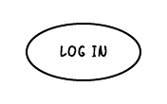

**Lock Types:** Read-only on **User** table

**Number of Locks:** Single

**Enabling Conditions:** None

**Frequency:** ?

**Consistency (ACID):** not critical, order not critical

**Subtasks:** Mother task not needed

### Abstract Code

* User enters username (*$userName*), password (*$password*)
* User clicks / enter ***login button***
  + **login validation process** executes
    - If userName exists and passwords match
      * add $User object with ($userId, $userName, $position, ...) to session
      * go to **Main form** 
        + enable Search, List for sale, view auction results
        + If *$User.is_admin* also enable

enable Category Report and User Report

Display *$position*

* + - else
      * return error message
      * go to **Login form**

## Register

### Task Decomp

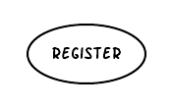

**Lock Types:** Read-Write on **User** table

**Number of Locks:** Single

**Enabling Conditions:** None

**Frequency:** ?

**Consistency (ACID):** critical that userName is unique

**Subtasks:** Mother is not needed

### Abstract Code

* User Enters: *$firstName. $lastName, $userName, $password, $confirmation*
* User clicks / enter ***register button***
  + **Registration validation process** executes
    - If all fields have data continue
    - else
      * return error message
      * go to **Register form**
    - If $password and $confirm match continue
    - else
      * return error message
      * go to **Register form**
    - If $userName is unique continue
    - else
      * return error message
      * go to **Register form**
    - (validation passed)
      * persist User data
      * add *$User* object with *($userId, $userName, $position, ...*) to session
      * go to **Main form** 
        + enable Search, List for sale, view auction results

## Add Item for Sale

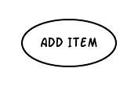

### Task Decomp

**Lock Types:** Read-Write on **Item** table

**Number of Locks:** Single

**Enabling Conditions:** None

**Frequency:** ?

**Consistency (ACID):** not critical

**Subtasks:** Mother is not needed

### Abstract Code

## Search for Items

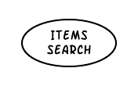

### Task Decomp

**Lock Types:** Read on **Item** table

**Number of Locks:** Single

**Enabling Conditions:** None

**Frequency:** ?

**Consistency (ACID):** not critical

**Subtasks:** Mother is not needed

### Abstract Code

## Item Search Results

### Task Decomp

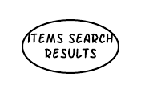

**Lock Types:** Read on **Item** table

**Number of Locks:** Single

**Enabling Conditions:** None

**Frequency:** ?

**Consistency (ACID):** not critical

**Subtasks:** Mother is not needed

### Abstract Code

## View Sales Item

### Task Decomp

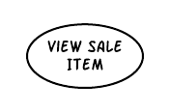

**Lock Types:** Read on **Item** table

**Number of Locks:** Single

**Enabling Conditions:** None

**Frequency:** ?

**Consistency (ACID):** not critical

**Subtasks:** Mother is not needed

### Abstract Code

## Bid on Item

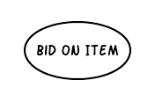

### Task Decomp

**Lock Types:** Read-Write on **Item** table

**Number of Locks:** Single

**Enabling Conditions:** None

**Frequency:** ?

**Consistency (ACID):** not critical

**Subtasks:** Mother is not needed

### Abstract Code

## Get Item Now

### Task Decomp

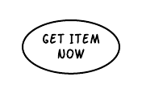

**Lock Types:** Read on **Item** table

**Number of Locks:** Single

**Enabling Conditions:** None

**Frequency:** ?

**Consistency (ACID):** not critical

**Subtasks:** Mother is not needed

### Abstract Code

## Update Description

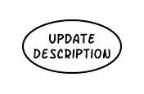

### Task Decomp

**Lock Types:** Read on **Item** table

**Number of Locks:** Single

**Enabling Conditions:** None

**Frequency:** ?

**Consistency (ACID):** not critical

**Subtasks:** Mother is not needed

### Abstract Code

## View Item Ratings

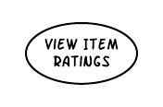

### Task Decomp

**Lock Types:** Read on **Item** table

**Number of Locks:** Single

**Enabling Conditions:** None

**Frequency:** ?

**Consistency (ACID):** not critical

**Subtasks:** Mother is not needed

### Abstract Code

## Add / Delete Item Ratings

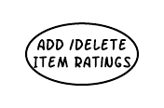

### Task Decomp

**Lock Types:** Read on **Item** table

**Number of Locks:** Single

**Enabling Conditions:** None

**Frequency:** ?

**Consistency (ACID):** not critical

**Subtasks:** Mother is not needed

### Abstract Code

## View Auction Results

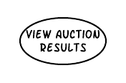

### Task Decomp

**Lock Types:** Read on **Item** table

**Number of Locks:** Single

**Enabling Conditions:** None

**Frequency:** ?

**Consistency (ACID):** not critical

**Subtasks:** Mother is not needed

### Abstract Code

## View Category Report

### Task Decomp



**Lock Types:** Read on **Item** table

**Number of Locks:** Single

**Enabling Conditions:** None

**Frequency:** ?

**Consistency (ACID):** not critical

**Subtasks:** Mother is not needed

### Abstract Code

## View User Report

### Task Decomp

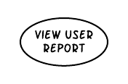

**Lock Types:** Read on **Item** table

**Number of Locks:** Single

**Enabling Conditions:** None

**Frequency:** ?

**Consistency (ACID):** not critical

**Subtasks:** Mother is not needed

### Abstract Code